Auteur(s): Youssef Amarti

Versie: 0.1

Status: Concept

Datum: 14 oktober 2014

ITopia is onderdeel van de

Hogeschool van Amsterdam

Versiebeheer

|  |  |  |  |  |
| --- | --- | --- | --- | --- |
| **Ver.** | **Status** | **Datum** | **Auteur(s)** | **Wijzigingen** |
|  |  |  |  |  |
|  |  |  |  |  |
|  |  |  |  |  |

**Goedkeuring**

|  |  |  |  |  |  |  |
| --- | --- | --- | --- | --- | --- | --- |
|  | **Uitvoering** | | **Controle** | | **Goedkeuring** | |
| **Ver.** | **Naam** | **Datum** | **Naam** | **Datum** | **Naam** | **Datum** |
|  |  |  |  |  |  |  |
|  |  |  |  |  |  |  |
|  |  |  |  |  |  |  |

Summary

Table of contents

1. Use case diagrams 4

2. Scenarios 5

3. Activity diagram 6

# Use case diagrams

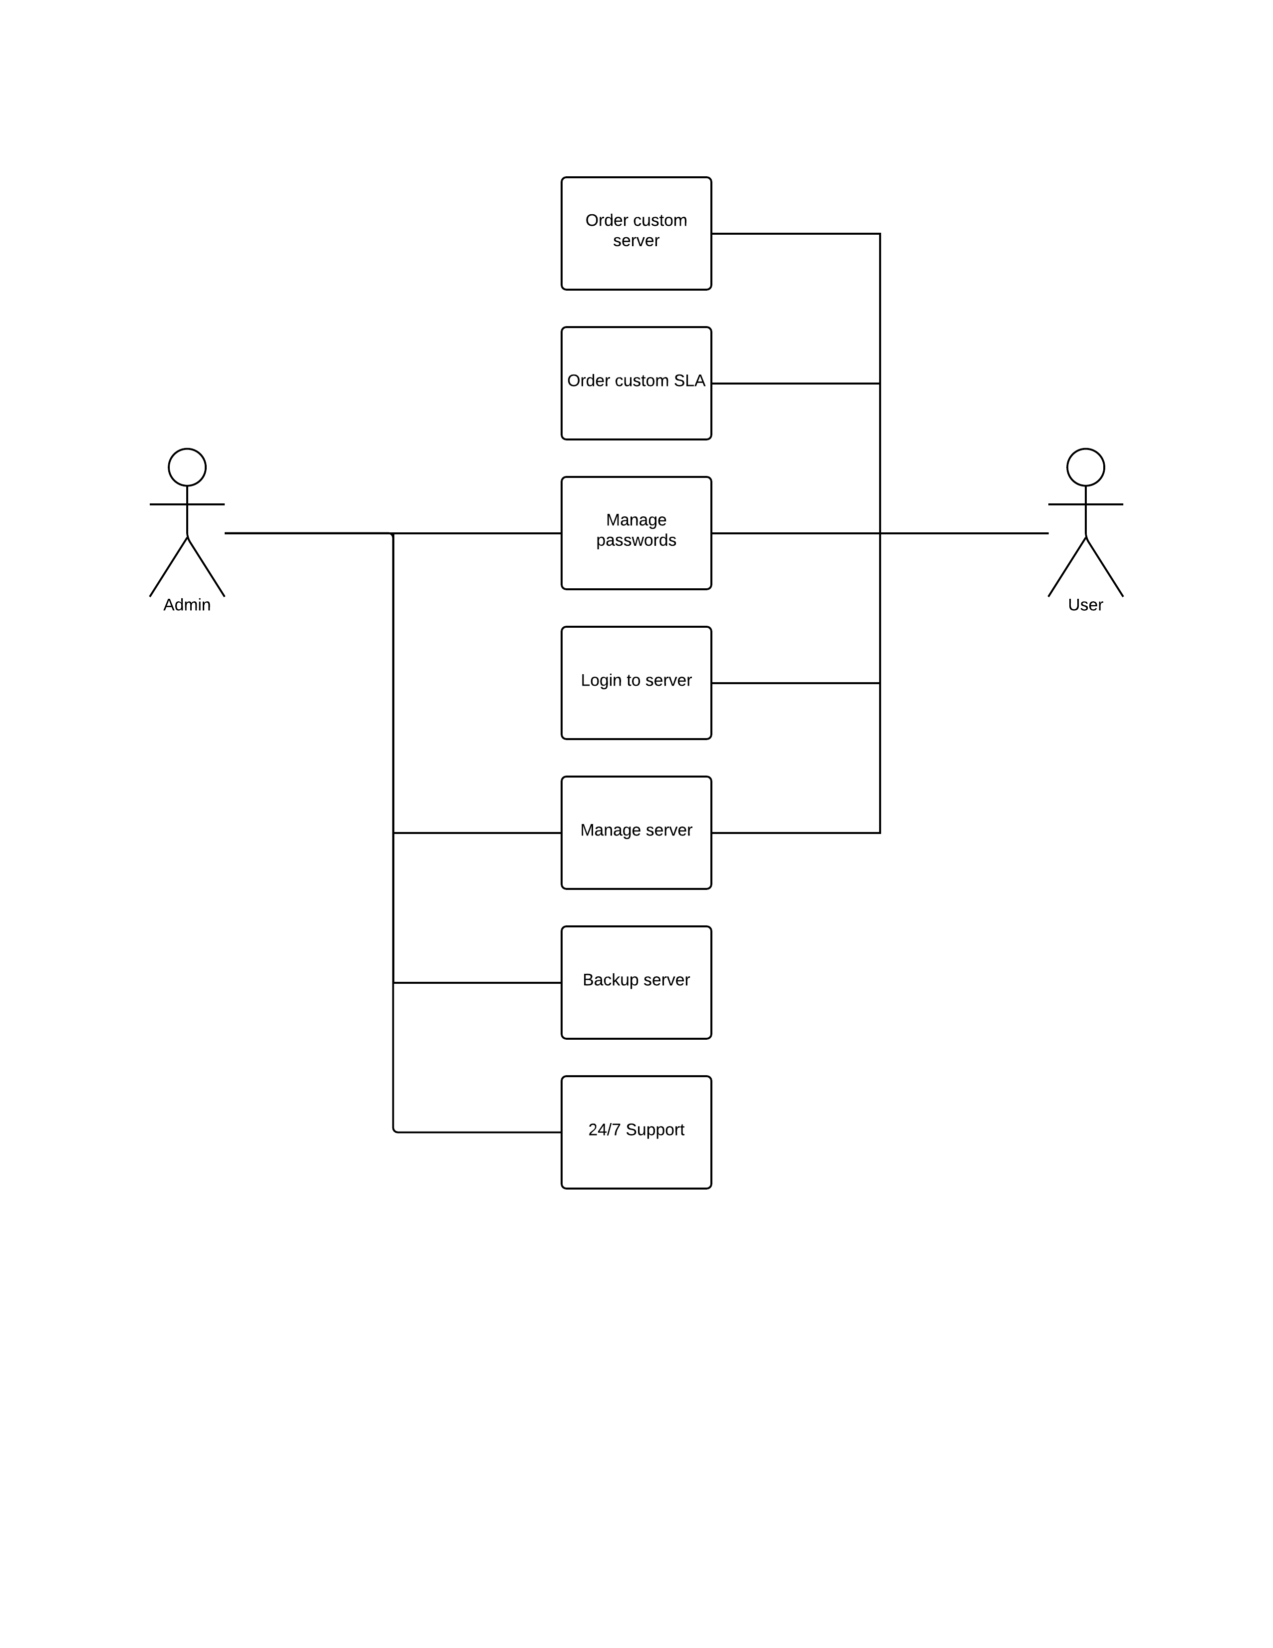

# Scenarios

|  |  |
| --- | --- |
| **Titel** | Make a user account |
| **Summary** | If client doesn’t have an existing user account |
| **Primaire actor** | User (client), System |
| **Precondities** | User doesn’t have a existing user account for plaintech |
| **Success guarantee** | User has to press one make a new account. Fill the form in and submit. |
| **Main success scenarios** | * User press one make a new account. * User fills out the form. * System checks if the account is new. * User submit his form. * System sends confirm link to email. * User confirms email. * User can now make use of his plaintech account |
| **Subscenario's** (Extensions) | * User already exists, user gets error message ”email already in use” * User terminates filling out the form * System can’t access database * System doesn’t send confirm email * User doesn’t confirm his email |

|  |  |
| --- | --- |
| **Titel** | Login |
| **Summary** | Client logs in to plaintech |
| **Primaire actor** | User (client), System |
| **Precondities** | User has a existing user account for plaintech  User is not logged on to plaintech |
| **Success guarantee** | User clicks on log in button,fills his username and password, user is logged on plaintech |
| **Main success scenarios** | * User press one log in. * User fills out his username. * User fills out his password. * System checks if the account exist. * System sends ok message. * User signd in to plaintech. * User can now make use of his plaintech website |
| **Subscenario's** (Extensions) | * System can’t access database * User doesn’t exist. * User closes plaintech website. |

|  |  |
| --- | --- |
| **Titel** | Order server |
| **Summary** | Client logs in to plaintech, orders a configured server packet, and checks out. |
| **Primaire actor** | User (client), System |
| **Precondities** | User has a existing user account for plaintech  User is logged on to plaintech |
| **Success guarantee** | User is logged on plaintech, user choices between pre configured server packets, and checks out. |
| **Main success scenarios** | * User logged on to plaintech. * User goes to order page * User chooses his pre configured server packet * User confirms his payment method * System checks his information * System send user log information |
| **Subscenario's** (Extensions) | * System can’t access database * User is not logged on to plaintech * Pre configured server packet is not available |

|  |  |
| --- | --- |
| **Titel** | Order custom server |
| **Summary** | Client logs in to plaintech, orders a custom server packet, and checks out. |
| **Primaire actor** | User (client), System |
| **Precondities** | User has a existing user account for plaintech  User is logged on to plaintech |
| **Success guarantee** | User is logged on plaintech, user choices between pre configured server packets, and configures the package to his needs, and checks out. |
| **Main success scenarios** | * User logged on to plaintech. * User goes to order page * User chooses his pre configured server packet * User can change amount of RAM * User can change amount of HDD * User can change amount of VCPU * User confirms his payment method * System checks his information * System send user log information |
| **Subscenario's** (Extensions) | * System can’t access database * User is not logged on to plaintech * The configured server packet is not available |

|  |  |
| --- | --- |
| **Titel** | Order SLA |
| **Summary** | Client logs in to plaintech, orders a custom or pre configured server packet, and custom or pre configured SLA and checks out. |
| **Primaire actor** | User (client), System |
| **Precondities** | User has a existing user account for plaintech  User is logged on to plaintech,  User has choosen his pre configured or custom server |
| **Success guarantee** | User is logged on plaintech, user choices between pre configured SLA, and checks out. |
| **Main success scenarios** | * User logged on to plaintech. * User goes to order page * User chooses his pre configured server packet or custom server packet. * User chooses his SLA * User confirms his payment method * System checks his information * System send user log information |
| **Subscenario's** (Extensions) | * System can’t access database * User is not logged on to plaintech * The SLA is not available |

# Activity diagram